#2.

(a)The detrend plot shows as following:

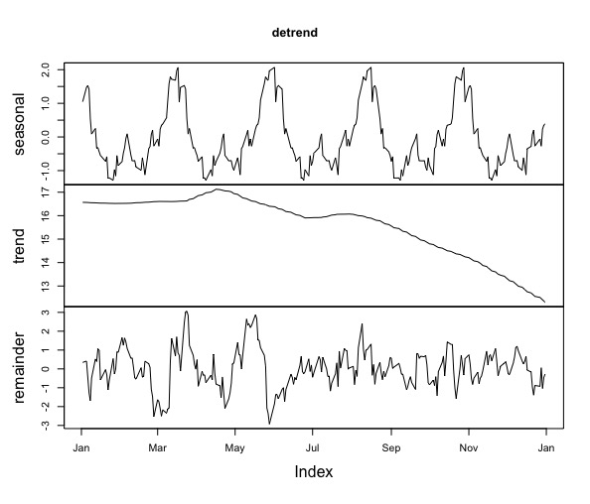

(b)The fitted plot in AR(1), MA(1), ARMA(1) show as followings:

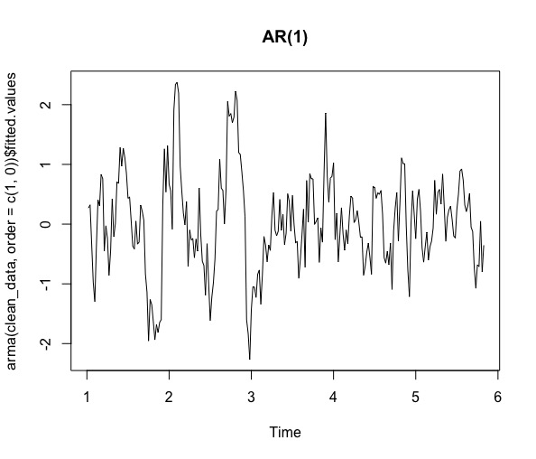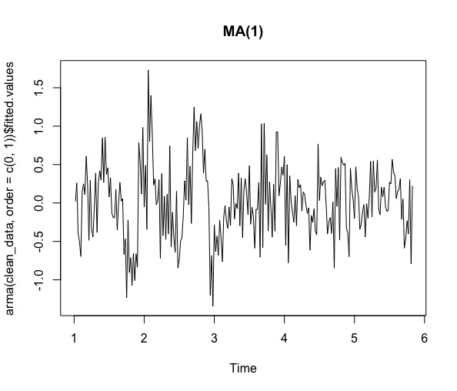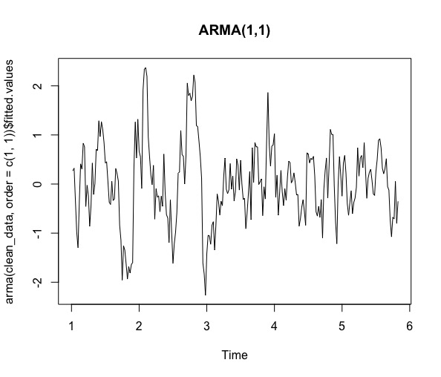

(c)Because of the AIC of three models, I choose to use AR(1)

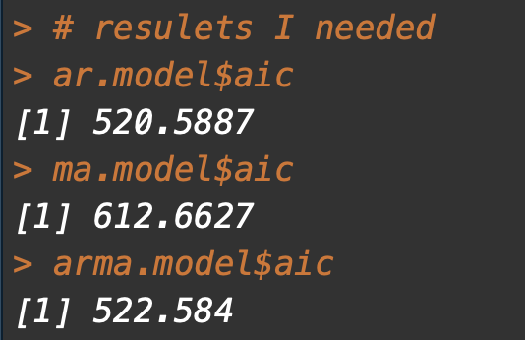

And the whole plot is:

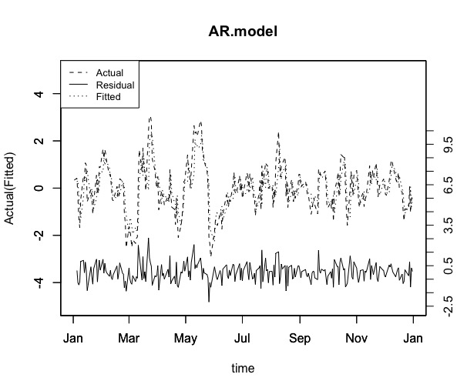

(d)The prediction plot shows as following:

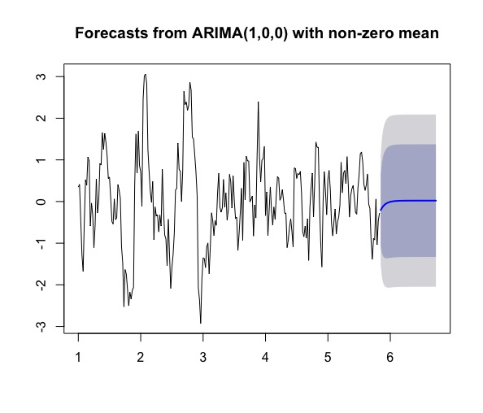

**Code**

# Topic: The Homework in Analysis of Time Series

# Name: YANG CHENYU

# Class: Financial Engineering 2

# Student ID:2016301550186

# load package----------------------------------------------

library(tseries)

library(lmtest)

library(tidyverse)

library(zoo)

library(forecast)

# set workspace----------------------------------------------

setwd('/Users/mac/Desktop/R_Time_Analysis/Homework 2')

# input data----------------------------------------------

data = read_csv('VIX1.csv')

# 1-------------------------------------------------------

sample_data <- filter(data, Date < as.Date('2005-1-1'))

sample_vix <- ts(sample_data$VIX, frequency = 52)

detrend_result <- stl(sample_vix, s.window = 'periodic')

detrend <- zoo(detrend_result$time.series, order.by = sample_data$Date)

clean_data <- detrend_result$time.series[,"remainder"]

plot(detrend)

# 2-------------------------------------------------------

plot(arma(clean_data,order = c(1,0))$fitted.values,main = 'AR(1)')

plot(arma(clean_data,order = c(0,1))$fitted.values,main = 'MA(1)')

plot(arma(clean_data,order = c(1,1))$fitted.values,main = 'ARMA(1,1)')

ar.model <- arima(clean_data,order = c(1,0,0))

ma.model <- arima(clean_data,order = c(0,0,1))

arma.model <- arima(clean_data, order =c(1,0,1))

# resulets I needed

ar.model$aic

ma.model$aic

arma.model$aic

actual <- zoo(clean_data,order.by = sample_data$Date)

fitted <- zoo(ar.model$fitted.values,order.by = sample_data$Date)

residual <- zoo(ar.model$residuals,order.by = sample_data$Date)

plot(actual, type = "l", ylim = c(-5, 5),main='AR.model',

ylab = "Actual(Fitted)",xlab = "time", lty = 2)

par(new = TRUE)

plot(fitted, type = "l", ylim = c(-5, 5),

ylab = "", xlab = "",lty = 3)

par(new = TRUE)

plot(residual,type="l",ylim = c(-2.5, 15),ylab = "", xlab = "",lty = 1, axes =FALSE)

axis(side = 4, at = c(seq(-2.5, 10.5, by = 1)), lab = c(seq(-2.5, 10.5,by = 1)),

ylab = "Residual", xlab = "")

legend("topleft", c("Actual","Residual", "Fitted" ), cex = 0.8,lty = c(2,1,3))

# 3-------------------------------------------------------

summary(ar.model)

forecast_data <- forecast(ar.model, h=47)

plot(forecast_data)